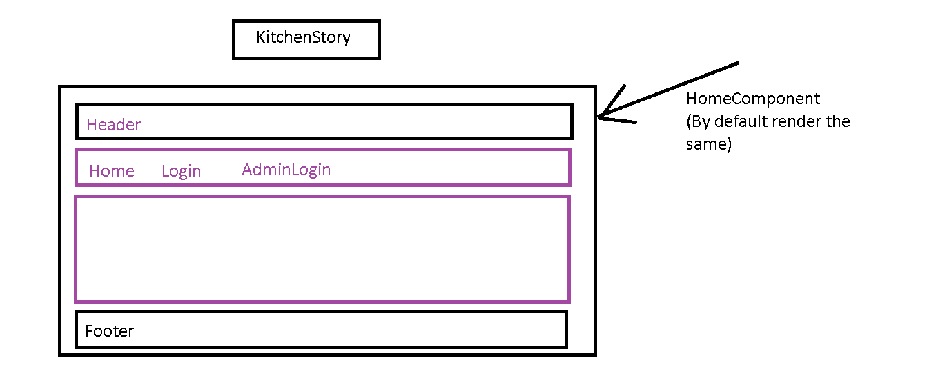

Login Component

You can create one service where include some dummy userid and password as an array so you can create authentication code

Then use this service in login component and take the user data from the form and validate

If correct then redirect user to product component.

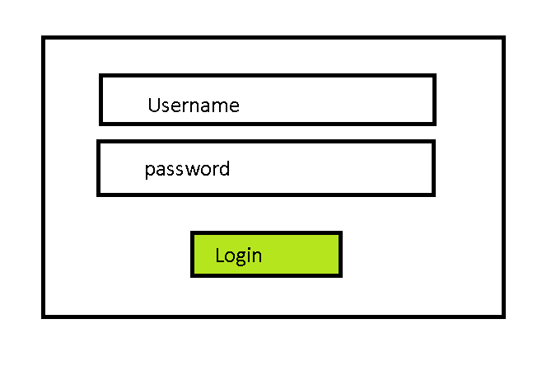

Create Product Model

Export class Product{

id:number;

name:string;

description:string;

price:number;

}

Product Page

Create a product service where you have product array

products: Product[];

ngOnIt(){

}

Write methods for addProduct, removeProduct, getAllProduct, getProductById

Create ListProductComponent

Display All Products

If user clicks on any one of product then show productdetails on ProductDetails Component.

Provide option to add product to cart.

If user selects products then Add Products in cart Array.

For cart create one more service named cart

cart: products[];

methods for addProductToCart, RemoveProductFromCart and getAllProductsCart

If user clicks on checkout

Then show CartPage

Show all products available In cart.

If user confirms then open the payment component confirm payments and just display Order summary.

Admin Login

Admin login page 🡪 display admin manage page

Where admin can add update and delete products.

Admin can also reset password.

Services

User service

Admin service

Cart service

Product Service

Components

homeComponent

UserLoginPage

AdminLoginPage

ProductList

ProductDetails

ViewCart

Checkout

Payment

Ordersummary

AdminManagePage

ChangePassword